Gun Story

DESIGN DOCUMENT

By Bunger for the 2025 Pirate Software Game Jam

**Introduction** **2**

Game Summary 2

Inspiration 2

Player Experience 2

Platform 3

Development Software 3

Genre 3

Target Audience 3

**Concept** **3**

Gameplay overview 3

Theme Interpretation (Sacrifice Is Strength) 4

Primary Mechanics 4

Secondary Mechanics 5

**Art** **6**

Theme Interpretation 6

Design 6

**Audio** **7**

Music 7

Sound Effects 7

**Game Experience** **7**

UI 7

Controls 7

**Development Timeline** **8**

## 

## Introduction

### Game Summary Pitch

Gun Story is a game about controlling sentient guns, who’s goal is navigate challenging terrain to get back to safety in the gun cabinet.

### Inspiration

**Toy Story**

The idea that you play as a gun that must hide the fact it is a gun comes mainly from this movie. Thinking about the events of Toy Story if instead it was sentient guns made me laugh.

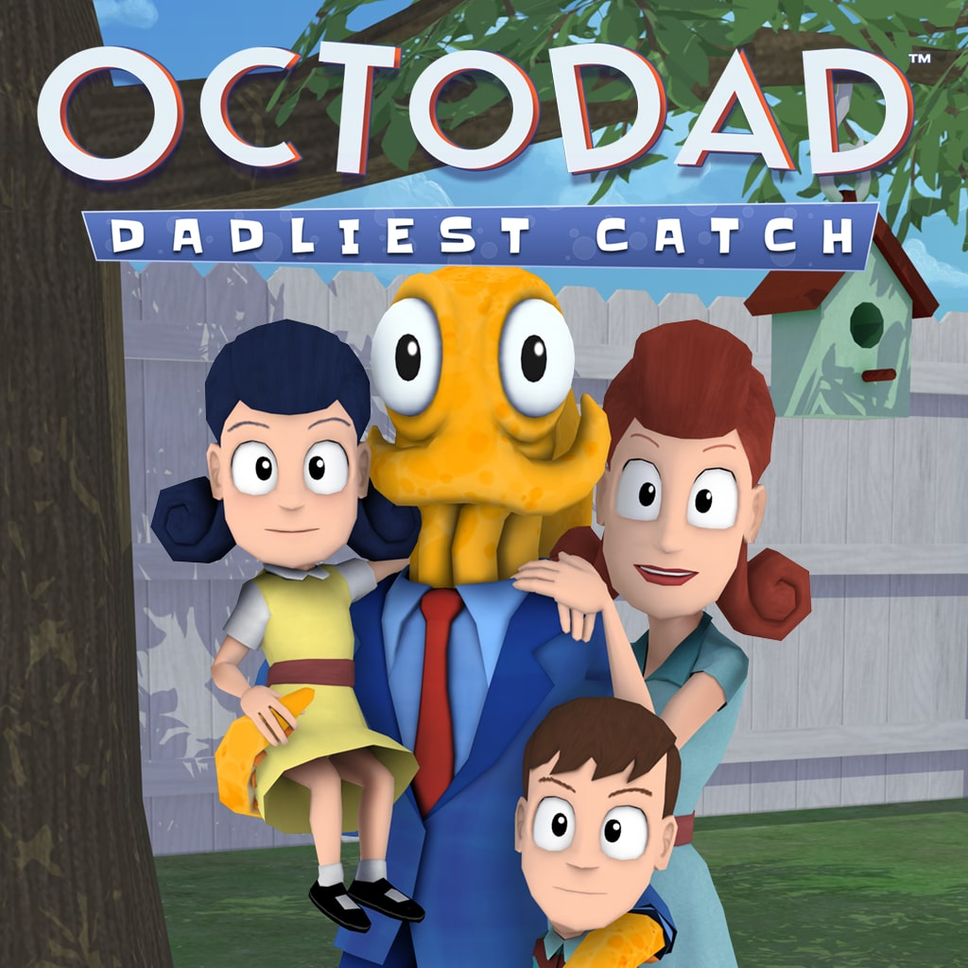**O**ctodad

Octodad’s gameplay is pretty clunky on purpose, and I want the way you maneuver the guns through the environment to mimic that difficulty. That, and I need my NPC to have the same level of awareness that the family has of their dad. And the fact that if you mess up enough, your cover is blown.

### Player Experience

In a single level, the user must be able to navigate 3 different guns (pistol, shotgun, rifle) back to their gun safety cabinet where they belong. They start out unsecure in the owners car, and they must avoid looking too suspicious in front of the humans in the process. You move by rolling as the guns, and depending on the type, your firing type allows you to fly by shooting. Pistol allows for small burst of air. Shotgun allows for a powerful, but chaotic flying experience. And the rifle is precise and powerful. If the human in the house notices you’re sentient, then its game over.

### Platform

The game is developed to be released on itch.io as a web app game

### Development Software

* Visual Studio for programming
* Unity for graphics and UI

### Genre

Singleplayer, stealth, platformer

### Target Audience

This game is meant for a casual audience, the gameplay provides some moderate challenges, but it is not meant for hardcore players.

## Concept

### Gameplay overview

You move by rolling as the guns, and depending on the type, your firing type allows you to fly by shooting. Pistol allows for small burst of air. Shotgun allows for a powerful, but chaotic flying experience. And the rifle is precise and powerful. If the human in the house notices you’re sentient, then its game over. The obstacle in the environment involve locked doors, half open windows, fans, the randomness of where you’ll land after firing, and the humans.

### Theme Interpretation (You Are The Weapon)

**This theme can be expressed in a number of different ways. Maybe you are cursed and become a weapon that other characters have to wield. Maybe you're an integrated organism that pilots a world destroying gun. Maybe you're Doom Guy. He's basically just a weapon, let's be real. Or even taking it a different direction maybe you're a weapon that kills things like viruses and saves people.**

The theme is taken literally, as in you are literally the gun. And while we like to think about weapons in the context of fighting, I wanted this game to be about gun safety, in whatever weird way I can express that.

### Primary Mechanics

| **Mechanic** | **Animated Mockup**  ***(Art not necessarily final)*** |
| --- | --- |
| **Guns** a  The 3 guns (pistol, shotgun, rifle) after different firing types that affect how they fly. Pistol is short and controlled, shotgun is large but chaotic, and the rifle is large and precise. The final gun is the combination of the previous 2 guns, so there’s a natural buildup to the final rifle. |  |
| **Human** a  When a human notices a gun flying about, they’ll become paranoid / suspicious. This is represented as a meter that builds up gradually through out the game, and doesn’t go down unless game over. |  |
| **Detection Meter**  **Detection Meter**  The detection meter sits at 0, and its game over when it hits 100. The meter will start building slowly at about a 0.5 tic per second after the gun is first in field of view of the human. This is because the gun isn’t where the human remembers they put it. So there’s a very small and gradual increase to keep the player moving a long.  In addition, every time the human sees the gun move, it will start building up at about 3.5 tics a second. If the human sees the gun firing, its game over. |  |
| **Bullets**  Each gun as an ammo capacity, and when it runs out, it reloads (somehow) for 3 seconds. The pistol has 8 ammo, the shotgun has 2, and the rifle has 16. |  |

### Secondary Mechanics

| **Mechanic** | **Animated Mockup**  ***(Art not necessarily final)*** |
| --- | --- |
| **House** a  You must navigate a house and the general amenities houses afford us. The idea is to make the ordinary features of a house to be an obstacle to over come. There are windows half ajared, there’s a mail slot on the front door, there’s a chimney you could fall through. Not to mentioned multiple rooms. |  |
| **KickBack Physics** a  I wanted to try adding a movement mechanic based around gun kickback. The momentum from the blast propels you through the environment.   * Pistol → Weakest, most controllable * Shotgun → Strongest, least controllable * Rifle → Strongest, most controllable |  |

## Art

### Theme Interpretation

This is just programmer art because I didn’t have time to coordinate a team. So it’ll be bear bones.

### Design

Honestly whatever I can implement myself as only a programmer.

## Audio

### Music

Ran out of time

### Sound Effects

Ran out of time

## Game Experience

### UI

There is a meter in the bottom left hand corner showing detection meter. There is a main menu that has an exit and start game game. There is a bullet meter that shows how many bullets are left in the gun before reload.

### Controls

**Keyboard**

Arrow keys / WASD

Left-click Mouse to shoot

Return Pause

## Development Timeline

**MINIMUM VIABLE PRODUCT**

| **#** | **Assignment** | **Type** | **Status** | **Finish By** | **Notes** |
| --- | --- | --- | --- | --- | --- |
| 1 | Design Document | Other | Finished | Jan 31, 2025 |  |
| 2 | Create Base House Foundation | Art | Finished | Jan 20, 2025 | Create the level environemtn based off a house |
| 4 | UI / Main menu | Coding | Finished | Jan 31, 2025 | Button UI, screen transition, title screen |
| 6 | WASD Movement | Coding | Finished | Jan 20, 2025 | Regular movement |
| 7 | Aiming Gun | Coding | Finished | Jan 29, 2025 | Freezing in space to line up a shot |
| 8 | Fire Bullet | Coding | Finished | Jan 20, 2025 | Apply kickback force to gun and keep track of reloading |
| 9 | Gun Safe | Coding Art | Finished | Jan 29, 2025 | The goal where the guns are supposed to go |
| 11 | Gun Models | Art | Finished | Jan 22, 2025 | Art for the gun |
| 13 | Pause menu | Coding Art | Finished | Jan 26, 2025 | Access to the main menu or resetting the level |
| 14 | Camera | Coding Other | Finished | Jan 26, 2025 |  |
| 15 | Enemy AI | Other  Coding Art | Finished | Jan 31, 2025 | Create levels 1 through 7 |
| 16 | End Screen | Other | Finished | Jan 31, 2025 | Create levels 7 through 15 |
| 18 | SUBMIT | Other | Finished | Jan 31, 2025 | Create Itch Page and upload |

**BEYOND (if ahead of schedule / extra time)**

|  |  |  |  |
| --- | --- | --- | --- |
| Extra levels | Other | Not started |  |
| Settings Menu | Coding | Not started | Volume slider, fullscreen toggle |
| More Advanced Enemy FOV | Coding | Not started | So that you can more accurately hide behind objects and be detected when peaking out |
| Lawn | Art | Not started | There was to be a lawn for decoration and story purposes |
| Environmental Story Telling | Art | Not started | There were supposed to be hints from various objects about the dangers of guns, but its 3 AM man |